**Data Visualization and Storytelling**

**• Create meaningful visualizations using data visualization tools**

**Code:-**

import matplotlib.pyplot as plt

import pandas as pd

excel_file="G:\\Ramesh VI\\Data Science\\Book1.xlsx"

df=pd.read_excel(excel_file)

print(df)

plt.hist2d(df['Seat No'],df['Total'])

#plt.hist(df['Total'])

plt.xlabel('Seat No')

plt.ylabel('Total')

plt.show()

a= int(input("Enter the Seat No: "))

print(df.iloc[a-1])

student_sub=df.iloc[a][["DS","CC","EH","WSN","CL"]]

subject=student_sub.index.tolist()

mark=student_sub.values.tolist()

plt.figure(figsize=(5,5))

plt.pie(mark,labels=subject,autopct='%1.1f%%',startangle=30)

plt.axis('equal')

plt.tight_layout()

plt.show()

**Output:**

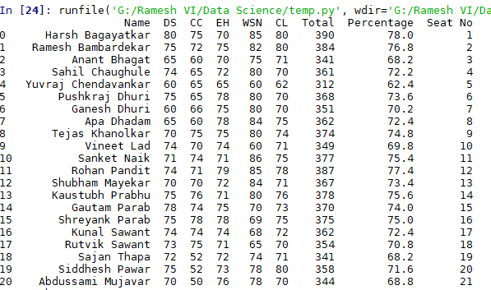

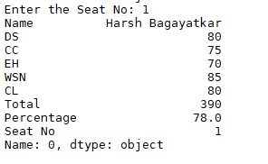

**Plot Histogram:**

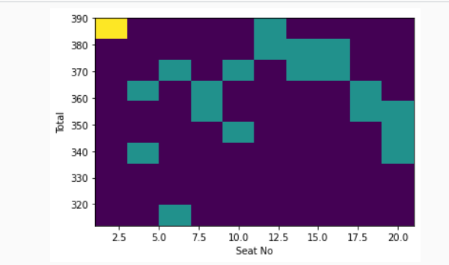

**Plot pie diagram:**

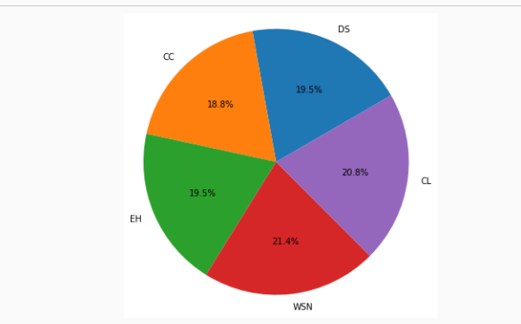

• Combine multiple visualizations to tell a compelling data story.

**Code:**

# importing pandas

import pandas as pd

# creating dataframe

df = pd.DataFrame({'Product': ['Carrots', 'Broccoli', 'Banana', 'Banana',

'Beans', 'Orange', 'Broccoli', 'Banana'],

'Category': ['Vegetable', 'Vegetable', 'Fruit', 'Fruit',

'Vegetable', 'Fruit', 'Vegetable', 'Fruit'],

'Quantity': [8, 5, 3, 4, 5, 9, 11, 8],

'Amount': [270, 239, 617, 384, 626, 610, 62, 90]})

pivot = df.pivot_table(index=['Product'],

values=['Amount'],

aggfunc='sum')

print("******Product with Amount*******")

print(pivot)

# creating pivot table of total

# sales category-wise aggfunc = 'sum'

pivot = df.pivot_table(index=['Category'],values=['Amount'],aggfunc='sum')

print("*****Category with total amount*****")

print(pivot)

pivot = df.pivot_table(index=['Product', 'Category'], values=['Amount'], aggfunc='sum')

print("***Product with Category and Amount***")

print(pivot)

# minimum of sales respectively

pivot = df.pivot_table(index=['Category'], values=['Amount'],

aggfunc={'median', 'mean', 'min'})

print(pivot)

pivot = df.pivot_table(index=['Product'], values=['Amount'],

aggfunc={'median', 'mean', 'min'})

print(pivot)

**Output:**

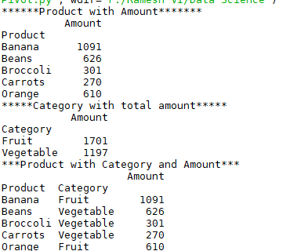

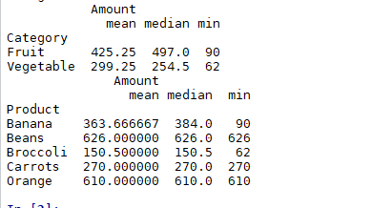

• Present the findings and insights in a clear and concise manner

**Code:**

import pandas as pd

import matplotlib.pyplot as plt

dfr=pd.read_csv(r'F:\Ramesh VI\Data Science\Book1.csv')

a=dfr.boxplot(column=["DS","CC","EH","WSN","CL"])

plt.show(a)

**Output:**

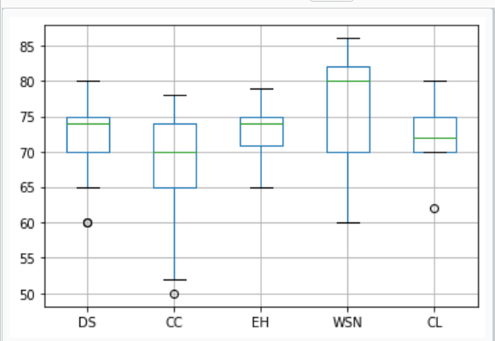

**Excel sheet:**

